Model Rocket PID Tuner

Guido di Pasquo[1]

1. INTRODUCTION

Since there have been an increase in model rockets with active control systems, mainly in the form of TVC, the question of how to tune a PID has arisen. The fundamental problem in PID tuning for model rockets is the cost of in-plant tuning, since each iteration, or flight, needs a new motor, and the risk of destroying the model in the process is high. For that reason, a simple, semi-plug and play, Python based, tuner has been developed.

1. PID TUNER UNDERLIYNG MODEL

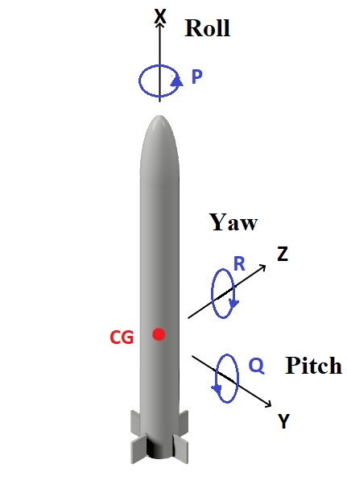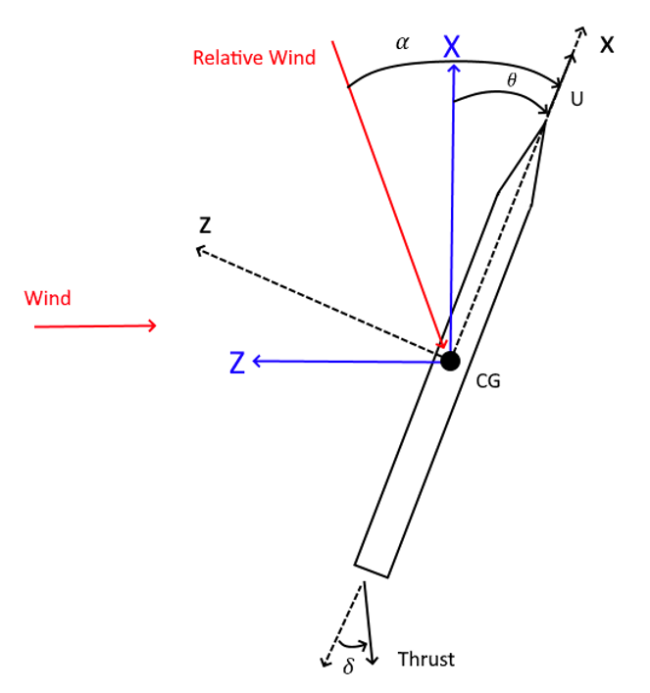

Figure 1 – Diagram of a model rocket, where Q is the pitch rate ($\dot{θ}(t))$.

The first step was to find the equations of motion for pitch in a model rocket, which are the following [1][2]:

|  |  |
| --- | --- |
|  | ( 1 ) |

And are be approximated to [1]:

|  |  |
| --- | --- |
| $$-C_{z_{α}}α\left(t\right)+\left(-\frac{mU}{Sq}\right)\dot{θ}\left(t\right)-C_{w}Sin\left[Θ\right]θ(t)=C_{z_{δ_{e}}}δ_{e}(t)$$ $$-C_{m_{α}}α[s]+\frac{I_{y}}{Sqd}\ddot{θ}\left(t\right)=C_{m_{δ_{e}}}δ_{e}(t)$$ | ( 2 ) |

The State-Space model is obtained:

|  |  |
| --- | --- |
| $$\left(\begin{aligned}\overset{.}{θ} \\ \ddot{θ} \\ \overset{.}{α}\end{aligned}\right)=\left(\begin{matrix}0 & 1 & 0 \\ 0 & 0 & \frac{C_{m_{α}}*Sqd}{I_{y}} \\ \frac{C_{w}Sin[Θ]*Sq}{mU} & 1 & \frac{C_{z_{α}}}{(\frac{mU}{Sq})}\end{matrix}\right)*\left(\begin{aligned}θ \\ \overset{.}{θ} \\ α\end{aligned}\right)+\left(\begin{aligned}0 \\ \frac{C_{m_{δ_{e}}}*Sqd}{I_{y}} \\ \frac{C_{z_{δ_{e}}}*Sq}{mU}\end{aligned}\right)*δ_{e}$$ | ( 3 ) |

Where S is the cross-sectional area of the rocket, q the dynamic pressure, d its diameter, U the longitudinal velocity, m its mass and Iy its moment of inertia. $θ$ is the pitch angle and its temporal derivatives, $Θ$ is the initial pitch angle, $α$ the angle of attack. $δ_{e}$ is the TVC angle (in radians). The rest of parameters are summed up in Table 1.

|  |  |  |
| --- | --- | --- |
| Parameter | Definition | Formula |
| $$C_{w}$$ | Gravity. | $$-\frac{mg}{Sq}$$ |
| $$C_{m_{α}}$$ | Moment variation with angle of attack. | $$\frac{{C_{N}}_{α}(x_{cg}-x_{a})}{Sqd }$$ |
| $$C_{z_{α}}$$ | Normal Force variation with alpha. | $$-{C_{N}}_{α}$$ |
| $$C_{m_{δ_{e}}}$$ | Moment variation with input angle. | $$\frac{Thrust*(x_{t}-x_{cg})}{Sqd}$$ |
| $$C_{z_{δ_{e}}}$$ | Normal Force variation with input angle. | $$\left(\frac{d}{(x_{t}-x_{cg})}\right)*C_{m_{δ_{e}}}$$ |

Table 1 – Aerodynamic and inertial parameters of a model rocket.

Where $x_{cg}$ is the distance from the tip of the nose cone to the center of mass, $x_{a}$ to the center of pressure and $x_{t}$ to the TVC mount, and ${C_{N}}_{α}$ is obtained from [2].

Knowing the State Space model, where C is assumed to be the Identity matrix, and D zero, it is discretized by Tustin’s method [3]:

|  |  |
| --- | --- |
| $$A_{d}={\left(\frac{2}{T}I-A\right)}^{-1}∙\left(\frac{2}{T}I+A\right)$$ $$B_{d}={\left(\frac{2}{T}I-A\right)}^{-1}∙B$$ $$C_{d}=C∙(A_{d}+I)$$ $$D_{d}=C∙B_{d}+D$$ | ( 4 ) |

Due to the extensiveness of these matrices, they are not shown here, but can be easily found in the program.

The actuator dynamics can have a detrimental effect in stability, so they have to be modeled. The transfer function of the servo is extracted from experimental data from [4]. Because the actuator is non-linear, the transfer function proposed is:

|  |  |
| --- | --- |
| $$\frac{K}{s^{2}+J.s+K}$$ | ( 5 ) |

Where K and J vary with the relative magnitude of the inputs.

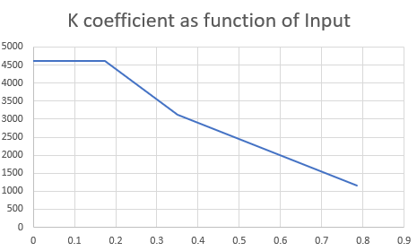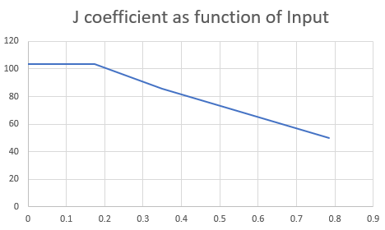

Figure 2 – A and B as a function of relative input (radians).

The relative magnitude of the inputs refers to the difference between an input and the previous one, is easy to note that an input from 40º to 45º is equivalent an a 5º input in the model.

The resulting State Space Model is:

$$\left(\begin{aligned}\dot{δ} \\ \ddot{δ}\end{aligned}\right)=\left(\begin{matrix}0 & 1 \\ -K & -J\end{matrix}\right)\left(\begin{aligned}δ \\ \dot{δ}\end{aligned}\right)+\left(\begin{aligned}0 \\ K\end{aligned}\right)u$$

where C is assumed to be the Identity matrix, and D zero. It is introduced into the program after discretization.

1. PID TUNER CODE

The details of the code will not be shown, instead the overall behavior is analyzed, followed by key points that have to taken into account when translating the gains obtained to a flight computer.

First, the block diagram of the controller used is analyzed:

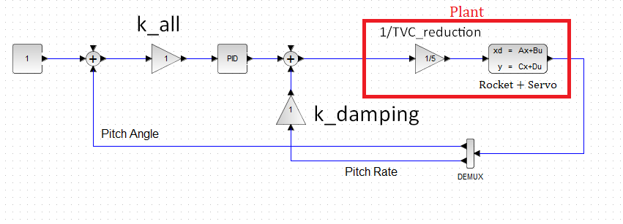

Figure 3 – Block diagram of the controller and model.

The user can choose between a step, ramp or constant zero input, based on the stability requirements for the system. This is done because non linearities like the actuator or maximum deflection angle can destabilize a stable system based on the input.

After the program begins, it updates parameters like U, q, ${C_{N}}_{α}$ based on the data from the rocket (as thrust and mass), and recalculates the model’s matrices. Disturbances as wind are computed, and their effects introduced as an equivalent input bypassing the actuator. Once the new states and outputs are calculated, they are treated as readings from sensors and are manipulated by the gains and PID, and a new input is computed. This process is repeated at each step of the simulation, ensuring that the flight is simulated from liftoff to burnout.

The reader should be careful when using the gains obtained by this method, since the flight computer code must match that of the simulator. Key points that should not be overlooked are:

* All angles are in radians, if not they are immediately divided by 57.3.
* The control scheme is found in the function *control_tita* and the PID scheme in *PID*.
* The output of the controller (*u_controler*) goes directly to the actuator, it should not be multiplied by the TVC reduction ratio, since it is already introduced in the simulation, and therefore in the calculated gains. If the user’s TVC mount has two reduction ratios, two sets of gains should be calculated.
* If the user decides to implement anti-windup, its structure must be carefully emulated to ensure the same effects, mainly the saturation at the PID output, as well as after the *k_damping* feedback.
* As for V0.2 of the simulator, where mass, moment of inertia and thrust are kept constant, the user should verify the gains obtained against the extremes of these parameters to ensure stability. Maximum Thrust with minimum moment of inertia should be the starting pair, since it is the most demanding on the control system.

1. CONCLUTIONS

The mathematical model of a model rocket has been developed, discretized and introduced into a simulator. The plug and play methodology has been achieved, due to the user only having to plug his rocket’s parameters and play with the gains.

1. REFERENCES

[1] - Automatic Control of Aircraft and Missiles - [John H. Blakelock](https://www.amazon.com/John-H-Blakelock/e/B001IZXBLG/ref=dp_byline_cont_book_1)

[2] - OpenRocket technical documentation - Sampo Niskanen

[3] - <https://dsp.stackexchange.com/questions/45042/bilinear-transformation-of-continuous-time-state-space-system>

[4] – SG90 Characterization. Guido di Pasquo, Alexis M. Caratozzolo, Tomás Ziroldo

<https://www.youtube.com/watch?v=fnq0u8TrlA4>

[5] – Everyone that posted tutorials on internet.

1. Aerospace Engineering student at “Universidad Tecnológica Nacional – Regional Haedo”. Buenos Aires, Argentina.

   guidodipasquo@gmail.com
2. In this project, positive elevator (TVC angle) induces positive pitch angle.